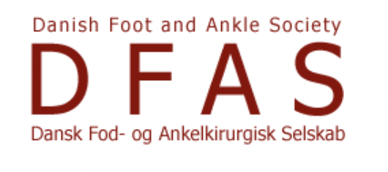

**Pes Planus: Posterior Tibial Tendon Insufficiency (PTTI) or**

**Progressive Collapsing Foot Deformity ( PCFD)**

Friday May 2, 2025

**Hotel Scandic Copenhagen**, Vester Søgade 6, Copenhagen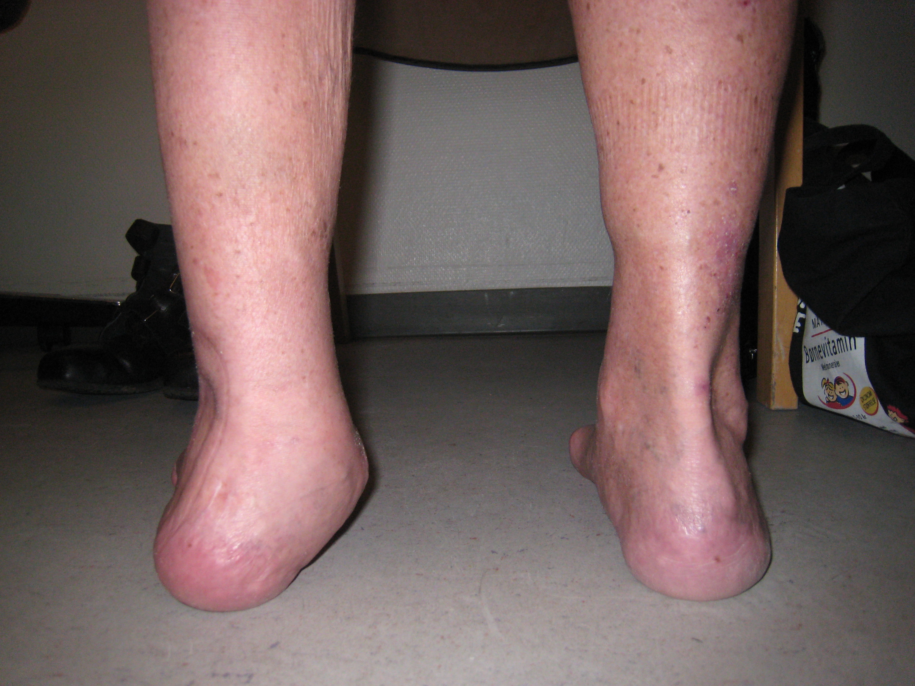

Conference Director Mr. Md. Dr. Mostafa Benyahia

**Faculty:**

Professor Fabian Krause , Schweiz

Professor Manuel Monteagudo, Spain

Dr. Robert Clayton, President of BOFAS, United Kingdom

Professor Hani El Mowafi, Egypt

Dr. Ole Rahbek, Denmark

Professor Bjarne Møller Madsen, Denmark

Dr Mostafa Benyahia, Denmark

**Final program:**

**08:50 Welcome to the course: Mostafa Benyahia**

9:00 Pes Planus: Posterior Tibial Tendon Insufficiency (PTTI) or

Progressive Collapsing Foot Deformity ( PCFD)   Why a new classification? Dr. Mostafa Benyahia

9.:20 What is a symptomatic flatfoot?

Prof. Fabia Krause

9:40 Which is the best method to document flatfoot deformity?

Prof. Fabia Krause

10.00 Discussion

**10:15 COFFEE BREAK**

10:40 Is flatfoot in adults the result of untreated flatfoot in children?

Dr. Ole Rahbek

11:00 Differences between surgical techniques in the two groups - children or adults.

Why Pediatric Orthopedic colleagues and us have a different approach?

Prof. Bjarne Møller Madsen

11:20 Discussion

**12:30 LUNCH**

13:15    Painful flatfoot collapse with talocalcaneal bony coalition

Prof. Manuel Monteagudo

13:40    Progressive Collapsing Foot: how to plan successful osteotomies

Dr. Robert Clayton

14:05    Keep it simple: Medial calcaneal displacement and Cotton Osteotomy.

Prof. Manuel Montegudo

14.30    Lateral column lengthening: Evans, Hinterman. Planning and surgical technique

Dr. Robert Clayton

**15:00 COFFEE BREAK**

15:20 The soft tissue components of flatfoot and its correction?

Dr. Robert Clayton

15:40    Report on complications - Bring your cases and discuss

Prof. Hani El Mowafi

16:10 Cases discussion from all faculty

17:00 End of the day - Mostafa Benyahia